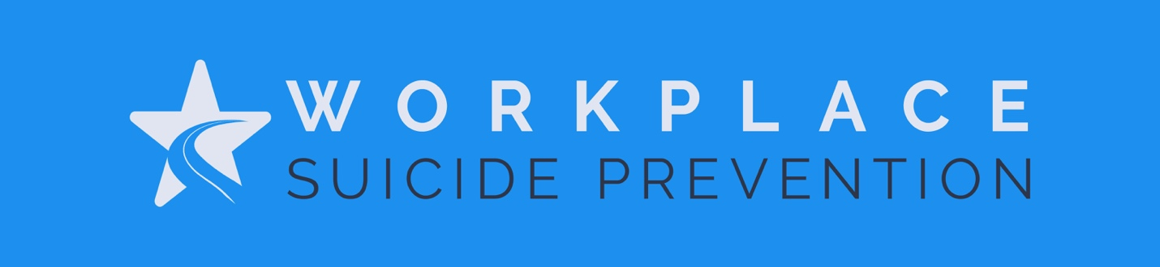

PROCLAMATION
[TEMPLATE]

National Suicide Prevention Month (#SPM)
National Suicide Prevention Week (#NSPW)
World Suicide Prevention Day (#WSPD)

WHEREAS; September is known in the United States as National Suicide Prevention Month [OR INSERT “The second week in September is National Suicide Prevention Week OR September 10th is World Suicide Prevention Day] and is dedicated to helping people live through suicidal intensity and suicide bereavement. Our goal is to take steps to prevent people from dying in isolation and despair by rekindling a passion for living; and

WHEREAS; Millions of people around the world join their voices to share a message of hope and healing. These observances are united in raising awareness that prevention is possible; treatment is effective; and people do recover; and

WHEREAS; Suicidal thoughts can affect anyone regardless of age, gender, race, orientation, industry, income level, religion, or background; and

WHEREAS; According to the Center of Disease Control (CDC), each year almost 50,000 people die by suicide; and

WHEREAS; In the US, suicide is the 10th leading cause of death among adults, suicide is the 2nd leading cause of death among people aged 10‐24, and upwards of 14 million people seriously consider suicide as they look to escape overwhelming pain; and

WHEREAS; The benefits of preventing and overcoming mental health challenges, suicide attempts and loss, and substance abuse are significant and valuable to individuals, families, our organization and our community at large; and

WHEREAS; Local and national mental health and suicide prevention advocacy and service organizations [INSERT examples of partnering organizations] are leading the way to hope and needing our partnership in the effort; and

WHEREAS; [INSERT ORGANIZATION] stands in solidarity with these efforts and chooses to publicly state and place our full support behind local educators, mental health professionals, and advocates as well as internal champions such as [LIST INTERNAL CHAMPIONS e.g., peer supporters, wellness coordinators, etc.] as partners in supporting our community who show up when people are having a hard time and serve as a compassionate bridge to resources; and

WHEREAS; Every member of our community should understand that throughout life’s journey we all need the occasional reminder that we are all fighting hardship in our own way; and

WHEREAS; We must encourage relatives, friends, co-workers, and others to recognize the signs of a problem, and guide those in need to appropriate services and supports; and

WHEREAS; We encourage all members of our community to take the time to inquire about the wellbeing of their loved ones and to genuinely convey their appreciation for their existence by any gesture they deem appropriate. A simple phone call, message, handshake, or hug can go a long way towards helping someone realize that they matter and that they are appreciated: and

NOW, THEREFORE, be it resolved that I, [ORGANIZATION LEADER], do hereby proclaim [CHOOSE ONE: the month of September/second week of September/September 10th], as [CHOOSE ONE: National Suicide Prevention Month /National Suicide Prevention Week/World Suicide Prevention Day] in the [INSERT ORGANIZATION]. Passed this [INSERT DAY} day of [INSERT MONTH AND YEAR]

___________________________________________________________________
[INSERT SIGNATURES & CREDENTIALS]

IN WITNESS WHEREOF, I have hereunto set my hand and caused the Seal of [ORGANIZATION} to be affixed on this [INSERT DATE].

Attest: ______________________________________________________________
[INSERT WITNESS & CREDENTIALS]

